Appendix A
Valley Craft Network Member Application
The Valley Craft Network (VCN) was formed in 1981 to provide an alternative format for a group of professional craftspeople in the Middletown and Pleasant Valley areas to display and market high quality craft items to the public.
Basic requirements for VCN members:
A. Must produce a high-quality craft or fine art that will appeal to the VCN Market.
B. Must have on display a minimum of $5,000 of merchandise ready for sale during the tour.
C. Must have a minimum of 300 customer names to whom VCN Tour information can be sent. Tour participants are expected to actively participate in marketing the event to their contacts and other connections
D. VCN members must attend membership meetings and also actively participate in the group’s marketing efforts for the tour. Some of those tasks include: maintaining VCN website, Facebook page and other social media; facilitating the organizing member/guest email lists; design & produce our yearly mailing/brochure, distribute brochures; publicity contacts for print promotion, and more.
E. Tour participants must be present during tour hours both days of the studio tour.
F. Must pay non-refundable dues of $200 at the first meeting of the year to show commitment and additional publicity costs as marketing material are determined.
G. As a member applicant you may apply to host a VCN Tour Stop or make arrangements to display with another member..

Requirements for hosting a VCN Tour Stop are:
• Studio must be clean and organized
• Studio must possess a professional and suitable ambiance
• Studio must be within our tour boundaries
• Studio must be accessible and have adequate parking
• Must provide a welcoming atmosphere, refreshments, and bathroom facilities to customers on the tour.
H. Applicants for membership must have their application/payment/images submitted to the group committee by January 11.
Tour Boundaries- See map below. Please reach out to us if you have questions about the boundaries.
To apply for full membership to the VCN please fill out the following application along with any additional publicity brochures, cards, photos, and/or examples of work.
Applications Fee is $25 made out to Valley Craft Network.
Please Email your completed application to valleycraftnetwork@gmail.com OR submit it online. If you would like to snail-mail your application, please download the form, print & fill it out and send it to: Caprikorn Farms, 20312 Townsend Rd., Gapland, MD 21779.
The membership committee will review your application. After review of your application and images, the group may want to see samples of your work in person, and in the case of a tour location, visit your studio/display area prior to making a final decision.

Appendix B
Valley Craft Network Guest Application
The Valley Craft Network (VCN) was formed in 1981 to provide an alternative format for a group of professional craftspeople in the Middletown and Pleasant Valley areas to display and market high quality craft items to the public.
Basic requirements for VCN Guest:
A. Must produce a high quality craft or fine art that will appeal to the VCN Market.
B. Must be within the VCN Tour boundaries (see map below)
C. Must have on display a minimum of $1000 of merchandise ready for sale during the tour.
D. Must have a minimum of 200 customer names to whom VCN Tour information can be sent as well as an active website and/or Facebook page. Guests are expected to actively participate in marketing the event to their contacts and other connections.
E. VCN guest must be present during tour hours both days of studio tour.
F. Guest Applicants must submit digital photos or samples of work to the VCN. Additional samples may be requested
G. If accepted, arrangements will be made with the hosting studio.
H. Artisans may participate as a “guest” for two consecutive years. After two years “guests” must become a VCN Member even if they choose to continue displaying at another member’s studio.
I. Applicants for guest membership must have their application/payment/images submitted to the group committee by January 11.
Tour Boundaries: See map below. Please contact us with questions regarding boundaries.
To apply for GUEST MEMBERSHIP to the VCN please fill out the following application along with any additional publicity brochures, cards, photos, and/or examples of work.
Applications Fee is $25 made out to Valley Craft Network.
The membership committee will review your application. Please email your completed application to valleycraftnetwork@gmail.com or submit your application online. If you would like to snail-mail your application, please download the form, print and fill it out and send it to:
Caprikorn Farms, 20312 Townsend Rd, Gapland, MD 21779

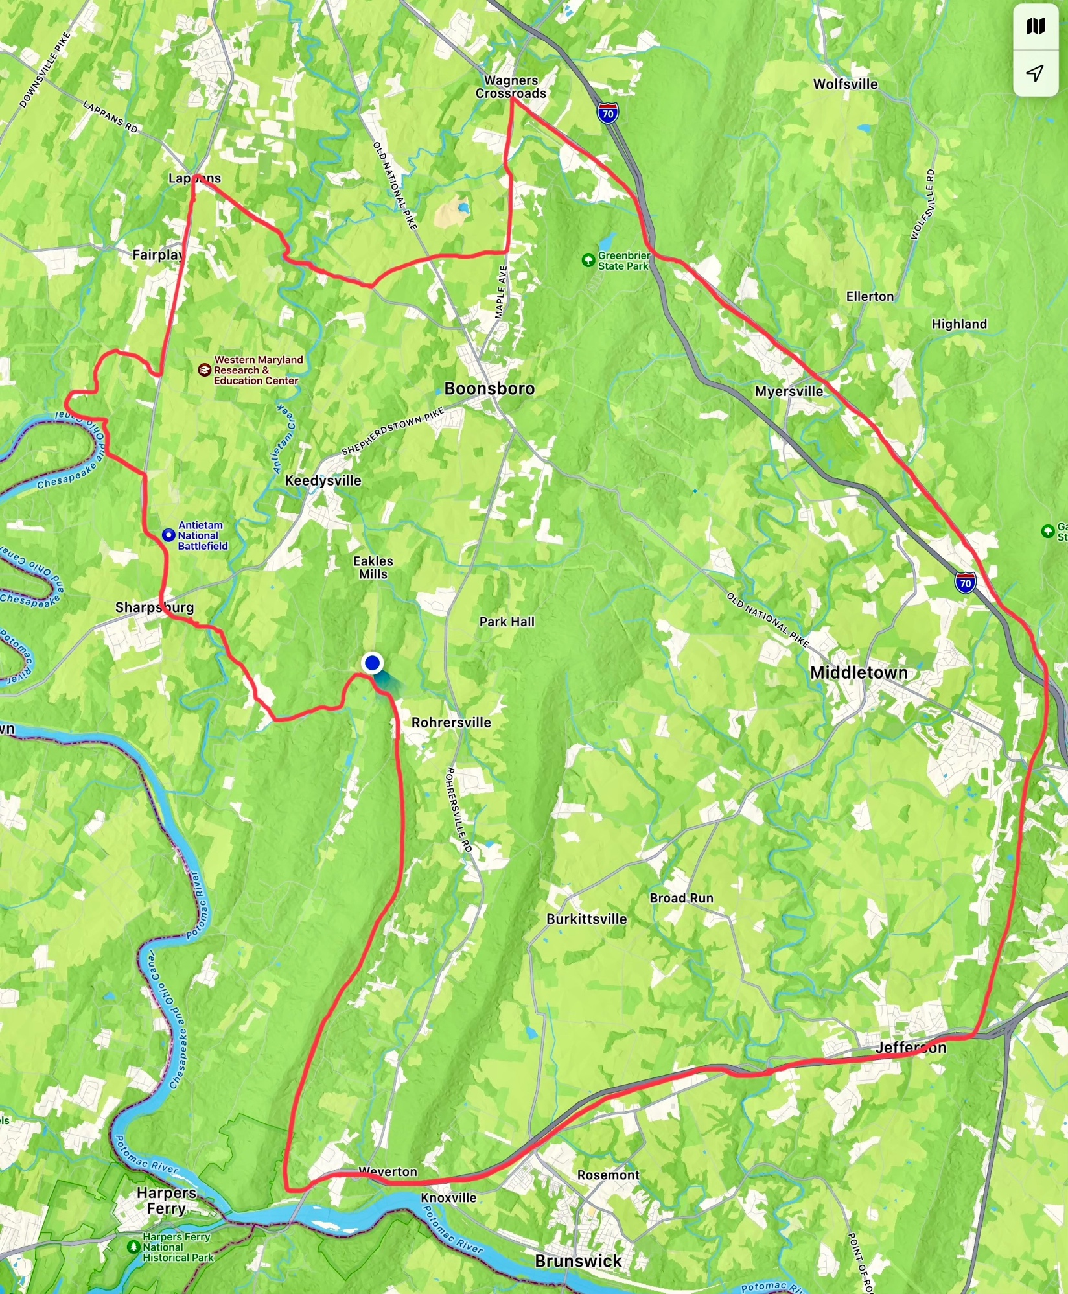

VCN Membership or Guest Application
Name:___________________________________________________________________________Name of your business if different from above: _________________________________________________________________________________ Address:__________________________________________________________________________ ________________________________________________________________________________
Phone:____________________________________________________________________________________
Email: ____________________________________________________________________________________
Description of work (including materials and techniques): ___________________________________________ __________________________________________________________________________________________ __________________________________________________________________________________________ __________________________________________________________________________________________
Price Points: ________________________________________________________________________________ __________________________________________________________________________________________
How long have you been involved in your craft/art? ________________________________________________
__________________________________________________________________________________________
What shows and/or exhibitions have you participated in within the last three years?
______________________ ________________________________________________________________________________________ ________________________________________________________________________________________ ________________________________________________________________________________________ ____________________________________________________________________
Where else do you sell your work? ______________________________________________________________ ________________________________________________________________________________________
________________________________________________________________________________________
Please provide the following as pertains to your craft/art:
Website address: _____________________________________________
Facebook Page: ______________________________________________
Instagram: __________________________________________________
Pinterest: ___________________________________________________
Other: _______________________________________________________

Do you mail information to this list about shows/exhibitions/sales? _______
Do you have an e-mail list? ______________ How many contacts? __________________
Would you need to display at another member’s location? _____________________
Do you have a studio and/or display area appropriate for hosting as a VCN location? _______________
Describe your parking and access to your studio. __________________________________________________________________________________________
_____________________________________________________________________________________________________________________________________________________________________________________________________________________________________________________________________________
Is there anything else you would like to share with us for consideration in your application? __________________ __________________________________________________________________________________________
I am applying for consideration as a Member________ Guest _______
I have reviewed the Basic VCN requirements: _________
Please sign. _________________________________________________________________
If more space is needed for your answers, please include an additional page.
Thank you for your application.
Applications are to be submitted via email: valleycraftnetwork@gmail.com.
Please include 12 images of your work.
The application fee is $25.00.
Checks should be made out to Valley Craft Network and mailed to:
Alice Orzechowski
c/o Caprikorn Farms
20312 Townsend Road
Gapland, MD 21779

